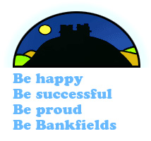
Bankfields Primary School
SMSC & British Values Whole School Yearly Long Term Plan: 2015-2016

NURSERY | Autumn  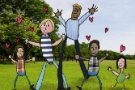  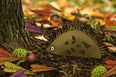  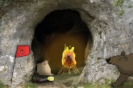  Why do you love me so much?  Can we explore it?  Why do leaves go crispy?  Autumn 1  1. We are all special.  2. We all know the rules.  3. Harvest Festival  Autumn 2  - Diwali  - Bonfire night  - Remembrance Day  - Christmas - celebrations | Spring  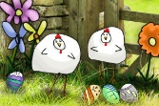  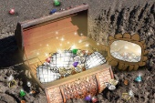  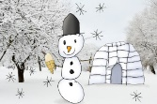  Where does snow go?  Is it shiny?  Are eggs alive?  Spring  - Chinese new Year  - Respect everybody  Spring 2  - Easter  - Pancake day/shrove Tuesday  We all count | Summer  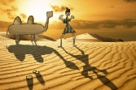  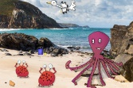  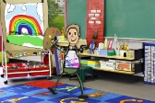  How many colours in a rainbow?  How many pebbles on the beach?  What is a shadow?  Summer 1  - We care for everybody  - Growing  - Looking after the environment  Summer 2  - New beginnings  - Growing up  - A very British afternoon tea (transition)
EYFS | Autumn 1  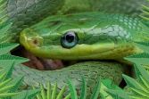  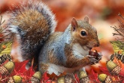  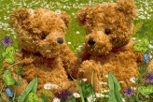  Do you want to be friends?  Why do squirrels hide their nuts?  Why don’t snakes have legs?  Autumn 1  1. We are all special.  2. We all know the rules.  3. Harvest Festival  Autumn 2  - Diwali  - Bonfire night  - Remembrance Day  - Christmas - celebrations | Spring 1  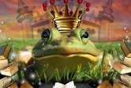  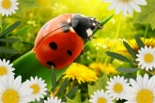  Will you read me a story?  What is a reflection?  Why do ladybirds have spots?  Spring  - Chinese new Year  - Respect everybody  Spring 2  - Easter  - Pancake day/shrove Tuesday  - We all count | Summer 1  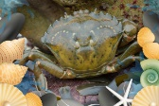  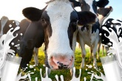  Do cows drink milk?  Who lives in a rock pool?  Are we there yet?  Summer 1  - We care for everybody  - Growing  - Looking after the environment  Summer 2  - New beginnings  - Growing up  - A very British afternoon tea (transition)
YEAR 1 | Superheroes – Autumn 1  Diversity and meeting the needs of those with disabilities.  Determination in the face of adversity  Good and bad choices | Moon Zoom – Spring 1  Aspirations and goals  Global Warming  Making new friends; being welcoming and showing  tolerance towards others. | 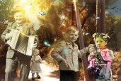  Memory Box – Summer 1  People that help us/ helping others  Growth and changes
 | 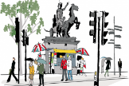  Bright Lights, Big City – Autumn 2  The Role of HM The Queen  Fire safety  Diwali and diversity | 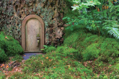  Enchanted Woodland – Spring 2  Caring for pets  Litter and wildlife  Rules in public places including | Dinosaur Planet – Summer 2  Controlling your temper  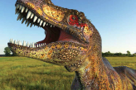  Using strength to help others
YEAR 2 | Land Ahoy! – Autumn 1  Being fair  Anti-bullying  Theft | 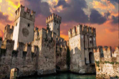  Towers, Tunnels and Turrets –Spr 1  Places where I feel safe  Similarities and differences (tolerance and respect) | 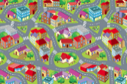  Street Detectives – Summer 1  Belonging  Being a good neighbour  Road safety
 | Muck, Mess and Mixtures – Autumn 2  Keeping clean (hygiene)  Following instructions | 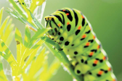  Wriggle and Crawl – Spring 2  What makes me special?  Moving house (habitats)  How I have changed (life cycles) | 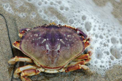  Beach Comber – Summer 2  Keeping beaches clean  Looking after our environment
YEAR 3 | Scrumdiddlyumptious! – Autumn 1  Healthy eating – nutrition  Organic foods  Children without food in the world | 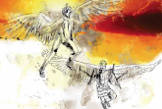  Gods and Mortals – Spring 1  Resolving differences  Democracy | Mighty Metals – Summer 1  Keeping safe when playing outside  The steel industry in our local area
 | 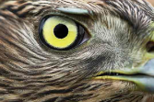  Predators – Autumn 2  Stranger danger  Animal welfare  Healthy teeth | 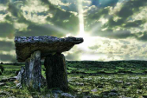  Tribal Tales – Spring 2  Indigenous tribes  ‘Good to be me’  Tribes from the Amazon who do not have contact with the outside world. | Urban Pioneer – Summer 2  Graffiti vs street art  Sun safety  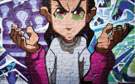
YEAR 4 | Potions – Autumn 1  The role of doctors and the emergency services  Harmful substances – drugs | 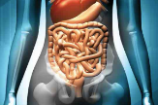  Bottoms, Burps and Bile – Spring 1  Exercise and healthy lifestyles  The discovery of penicillin  Hand washing | 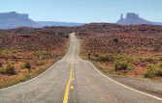  Road Trip USA – Summer 1  Electrical safety  In the context of Pocahontas, discuss how one person can make a difference  Discuss the issues of the Cherokee removal in 1838
 | Playlist – Autumn 2  The gift of hearing  What makes a good listener?  British Sign language | Misty Mountain Sierra – Spring 2  Facing new challenges  Cleveland Mountain Rescue (Fundraising) | Blue Abyss – Summer 2  Saving water  Orcas in captivity – SeaWorld.
YEAR 5 | 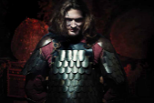  Peasants,Princes and Pestilence Autumn 1  Changes – SEALs theme  The British Monarchy  Crime and punishment | Star Gazers – Spring 1  Discuss the issue of immigration in the context of aliens  Keeping safe in cyberspace. | 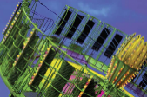  Scream Machine – Summer 1  Enterprise focus  Overcoming fear  Resolving conflict (Getting on and falling out)/How.  to deal with bullying if it arises
 | 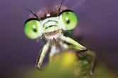  Beast Creator – Autumn 2  Plight of the bumblebee’ and work of the Bumblebee Conservation Trust  Debating ethical issue of three parent babies to reduce genetic disorders  A recipe for a successful community. | 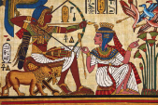  Pharaohs – Spring 2  Treasuring memories to help us deal with bereavement  Jealousy | 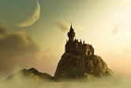  Alchemy Island – Summer 2  Recipe for the perfect class and school  A recipe for friendship  King Midas – greed
YEAR  6 | 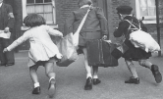  A Child’s War - Autumn 1  Family break up  Standing in someone else’s shoes – empathy  Charities and their importance | 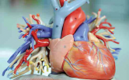  Blood Heart – Spring 1  Caring for the elderly  The advances of heart surgery techniques - heart lung bypass, open heart surgery  Discuss making a sacrifice for someone you love | Hola Mexico! – Summer 1  The discovery of chocolate – link to Fairtrade  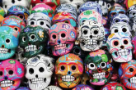  Enterprise project.
 | Frozen Kingdom – Autumn 2  Melting of the ice caps – Global Warming  Endangered species  How people adapt to changing  circumstances and new situations | Tomorrow’s World – Spring 2  What job could I do? – aspirations  A world without child slavery – Unicef  The Rights of the Child – Unicef | ID – Summer 2  Sex and Relationships Education  We are all unique – what makes us all special.

EG February 2016

