Hi to all Bankfields children,

I thought I would send a message to you all to say I hope you are missing being in the art studio as much as I am, I’m certainly missing making wonderful works of art with you all. I’m guessing that lots of you will have been making rainbow pictures and I’ve seen some of the fabulous art work that the children who have been in school have been making.

I also wanted to tell you about a website that has lots of creative activities for you to try **www.tvclp.org**

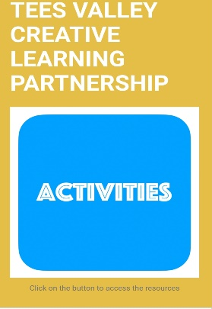

If you click on the blue activities button on the home page you will see 5 new activities with the theme of “Home”. You might want to try the drawing one, the looking carefully kind of drawing that we do in art sessions, and maybe you could try this with all the people who live in your house.

I would love to see what you create so please take a photo of some of your work and send it to [Sara@thestartstudio.co.uk](mailto:Sara@thestartstudio.co.uk). or use the hashtags on the picture below

**PARENTS**

The website has ideas for children to have fun with and may not turn out like you expected them to, that’s ok! The great thing about Art is there is no right and wrong way.

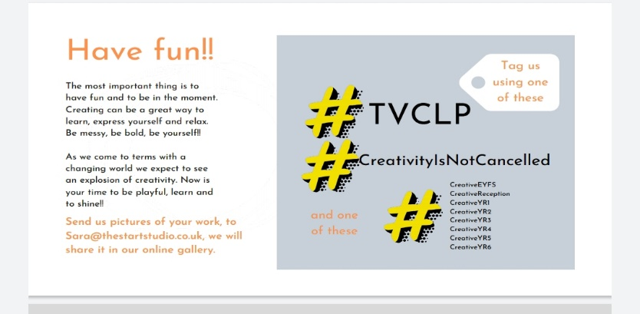

Stay at home, keep safe, keep creating and have fun!

Mrs Barker

