Bankfields Primary

School

Music Policy



October 2023

**Music Policy**

This document is a statement of the aims, principles and strategies for the teaching and learning of music at Bankfields Primary school.

**What is music?**

Music is a foundation subject within The National Curriculum. The fundamental skills, knowledge and concepts of the subject are set out in Key Stage 1 and Key Stage 2 of The National Curriculum where they are categorised into a single attainment target called music.

In the Foundation Stage (Nursery and Reception) basic musical skills are covered within the area of learning :expressive arts and design

Music is a universal language that embodies one of the highest forms of creativity.

**The purpose of music in the Primary Curriculum**

A high-quality music education should engage and inspire pupils to develop a love of music and their talent as musicians, and so increase their self-confidence, creativity and sense of achievement. As pupils progress, they should develop a critical engagement with music, allowing them to compose, and to listen with discrimination to the best in the musical canon.

**The aims of teaching music are:**

The national curriculum for music aims to ensure that all pupils:

* perform, listen to, review and evaluate music across a range of historical periods, genres, styles and traditions, including the works of the great composers and musicians
* learn to sing and to use their voices, to create and compose music on their own and with others, have the opportunity to learn a musical instrument, use technology appropriately and have the opportunity to progress to the next level of musical excellence
* understand and explore how music is created, produced and communicated, including through the interrelated dimensions: pitch, duration, dynamics, tempo, timbre, texture, structure and appropriate musical notations

**Statement of intent for music**

Our vision at Bankfields is that we aim to inspire children to develop creativity, imagination and self-expression through music. We aim for the children to gain a strong understanding of what music is through listening, singing, playing, evaluating, analysing, and composing across a wide variety of historical periods, styles, traditions, and musical genres. At Bankfields, we want the children to develop a curiosity for the music, as well develop their talent as musicians, and so increase their self-confidence, creativity and sense of achievement.

The children are given the opportunity to play and develop musicianship both through the curriculum and our links with TVMS. They learn to play a variety of instruments including the recorder, Violin, Taiko drums, ukulele, P-bone, Samba instruments, African drums and steel pans. In doing so, they begin to understand the different principle of each method of creating notes, as well as how to read basic music notation

Ultimately, we want our children to develop a life-long love and appreciation of music

**Timetabling of music lessons:**

Practical musicianship is taught in KS2 in association with TVMS and school staff. A variety of instruments are taught, with every child in KS2 learning to play an instruments on a rolling programme, violin and recorder

I n Key Stage 1, Year2 learn to play djembe drums in association with TVMS and Year 1 learn and sing in a interschool music ensemble .

In EYFS, musical instruments are available in the zones and outdoor areas

Throughout Bankfields Primary, Music is also taught through our carefully planned music curriculum, based on the KAPOW music programme. The music curriculum focuses on developing the skills, knowledge and understanding that our children need to become confident performers, composers, and listeners. Our curriculum introduces children to music from all around the world and across generations, teaching children to respect and appreciate the music of all traditions and communities.

**Teaching and learning:**

**Foundation Stage:**

We teach music in the Foundation Stage through the expressive arts and design strand of the profile and the Kapow music programme. The profile is used as guidance to ensure progression and continuity for children from 3 to 5 years. A programme of themes in the Foundation Stage ensures that children are offered increasing challenge and motivation in music as they progress through the school, providing a firm foundation for entry to the KS1 National Curriculum. Music within the Foundation Stage is taught using a cross-curricular approach, with singing and music making being an important part of the curriculum. Singing is used to teach numbers, topics and English such as nursery rhymes and alphabet work

**KS1**

Pupils are taught to:

♣use their voices expressively and creatively by singing songs and speaking chants and rhymes

♣play tuned and untuned instruments musically

♣listen with concentration and understanding to a range of high-quality live and recorded music

♣experiment with, create, select and combine sounds using the inter-related dimensions of music.

**KS2**

Pupils are taught to sing and play musically with increasing confidence and control. They develop an understanding of musical composition, organising and manipulating ideas within musical structures and reproducing sounds from aural memory.

Pupils are taught to:

♣play and perform in solo and ensemble contexts, using their voices and playing musical instruments with increasing accuracy, fluency, control and expression

♣improvise and compose music for a range of purposes using the inter-related dimensions of music

♣listen with attention to detail and recall sounds with increasing aural memory

♣use and understand staff and other musical notations

♣appreciate and understand a wide range of high-quality live and recorded music drawn from different traditions and from great composers and musicians

♣develop an understanding of the history of music

**Music Curriculum Planning**

Planning of the music curriculum takes place within teams and with liaison with the subject leader, Head teacher and TVMS . Our staff have created a music curriculum based on the KAPOW scheme (alongside the expectations in the 2014 National Curriculum) and have carefully considered the key knowledge, skills and key concepts* that will be developed in each year group. Our curriculum ensures that the children’s knowledge, skills and understanding of key concerpts progresses each year and builds on what has been taught in previous years.

Planning is supported and reviewed by the subject leader on a termly basis. This ensures that children have complete coverage of the National Curriculum without having to repeat themes and instrument tuition . When planning, we ensure that we carefully consider the individual needs of all of our pupils. An overview of our themes in music can be seen below.

*Key concepts are : performing, listening, composing and history of music

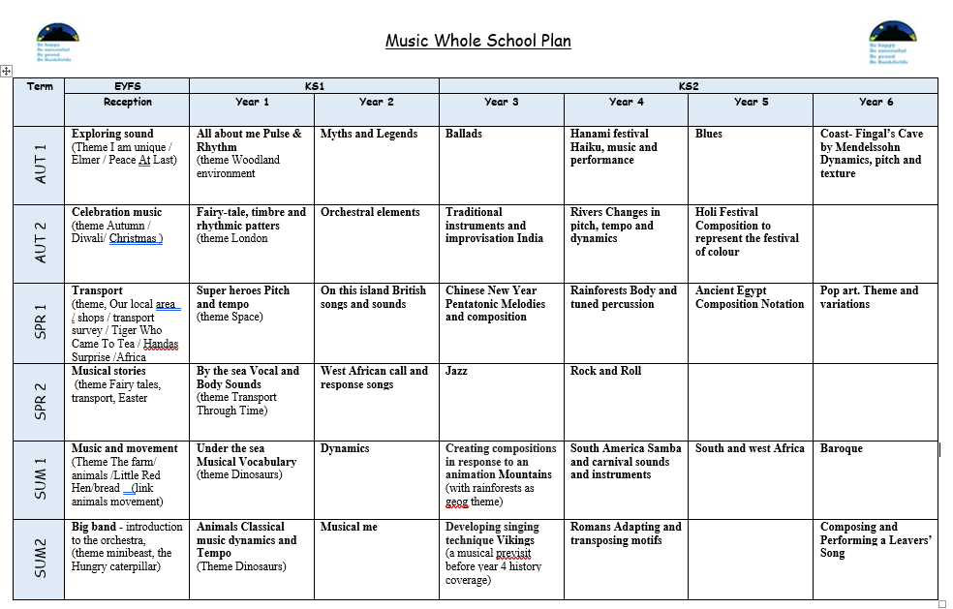

**The contribution of music in other curriculum areas**

Music provides an abundance of opportunities for cross curricular approaches. Where relevant and appropriate a thematic approach is adopted. Information and communication technology (ICT) plays an important role in the teaching of musical skills and knowledge. IPADS have enhanced the teaching and learning of music throughout the school. Children are able to compose , perform, record and review music using apps such as garage band.

Additionally children are able to research and appreciate music through sites with specific guidance such as itunes, youtube and spotify

In Physical Education (Dance) music plays a significant part. Music is used to inspire, create, perform and enhance dance and movement, linked to the themes and skills and knowledge being covered

In Religious Education music is used during assembly and for the teaching of hymns as an act of worship. The hymns that are taught and sang often have a story which is associated with them and retold to the children during the session.

In foundation and KS1 music is linked to English and mathematics by teaching children nursery rhymes, spelling patterns, alphabet, number sequence, bonds and tables

**Assessment**

We assess the children’s work in music through formative assessments as we observe the children during lessons and performance against a set of key knowledge and skills. This is the key knowledge we want our children to retain and the skills we want them to develop through our music curriculum. This assessment enables teachers to identify strengths and areas for development, which informs future teaching and learning. Specialist teachers from TVMS also inform class teachers of individual pupils progress, which informs our ongoing assessment of progress and annual reporting to parents

**Inclusion**

Bankfields Primary School values the individuality of all children. We are committed to giving all our children every opportunity to achieve the highest of standards. We do this by taking account of pupils' varied life experiences and needs. We offer a broad and balanced music curriculum and have high expectations of all our children. The achievements, attitudes and well-being of all our children matter. The inclusion policy helps to ensure that the school promotes the individuality of all our children, irrespective of ethnicity, attainment, age, disability, gender or background. We ensure that our SEND and gifted and talented children have the appropriate support and challenge across the music curriculum.

**Roles and Responsibilities**

The roles and responsibilities of the music subject leaders include:

* supporting staff with planning, visitors and resources
* leading working party meetings
* liaising with music subject leaders across the Trust through subject leader networks to share best practice
* leading Inset training
* monitoring standards and outcomes in music teaching and learning across the school by carrying out lessons observations and watching performances and work samples and speaking to the children about their learning
* taking the lead in policy development and the adaptation and integration of skills progression
* keep up to date with developments in the music curriculum and disseminate information to colleagues as appropriate
* provide a range of live music, including during weekly assembly
* liaise with outside agencies to develop the provision for instrument playing
* liaise with local community groups to arrange a platform for the children to perform and showcase their talents

**Parental and community involvement**

At Bankfields, we strive to have an excellent relationship with parents and the wider community. For many years we have endeavoured to be approachable and welcoming to our parents by holding a number of performances, specifically at Christmas and the end of the academic year. Our children also participate in a number of events within the wider community, putting their musical knowledge and skills to good use. In addition, we formally report on music to parents at the end of each school year and at regular parent consultations. Where appropriate, we would report to governors with regards to music in the termly head teacher’s report. We also make use of local resources and any appropriate visitors, music services.