**Bankfields Primary School**

**PE Policy**

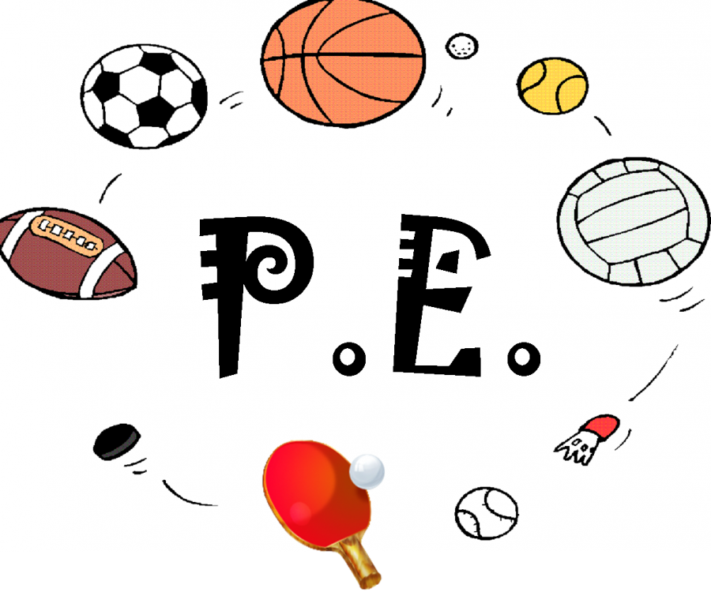



**2023 – 2024**

Vision

At Bankfields, we believe that all children should have the opportunity to live healthy and active lives. We aim to inspire, challenge and motivate children so they can thrive and express themselves confidently in a wide range of sports. It is important we allow the children to thrive in sport through exploring, dreaming and discovering their full potential. We aim to make meaningful links to other areas of the curriculum.

In PE, it is important that our children ‘learn to lead’. Therefore, we offer the opportunity for children to lead activities during their school life. Leadership gives children the understanding of what it is like to have responsibility, to show respect for rules and brings the added challenge of organisation, communication and teamwork. Throughout school, we strive to give as many children as possible the opportunity to participate in a variety of competitive sports during their school life, giving them the understanding of: what competition feels like, what it is like to be part of a team, and to be able to both win and lose with equal grace.

Our vision for Physical Education is that every child should have the opportunity to develop the physical confidence and competence to enjoy being active through a wide range of activities. We hope this will lead to a life-long passion of being physically active and healthy. Teachers will cater every lesson to children’s individual needs. This develops the pupils’ physical competence and confidence and their ability to use these to perform in a range of activities. We aim to improve their skills, physical development and knowledge of the body in action. We understand how important it is for children to be resilient when facing difficult challenges, and we believe PE is vital for developing this.

Teachers will promote positive attitudes towards healthy and active lifestyles. This will help pupils to plan, perform and evaluate actions, ideas and performance to improve their aptitudes, abilities and preferences. This will allow children to make choices about how to get involved in lifelong physical activity.

Bankfields Primary School seeks to provide a full, varied and interesting Physical Education curriculum, which is challenges, engages and excites staff and pupils. We believe Physical Education is a vital part of the education experience, and we want to install positive views around PE. The health and fitness of all of our children is paramount.

PE Concepts

* Competence
* Creativity
* Healthy Active Lifestyles
* Knowledge and Understanding
* Physical and Motor Development

Intent

At Bankfields Primary School, Physical Education is an integral part of our Curriculum that engages pupils in a supportive and challenging environment. We inspire to impact the pupil’s passion to maintain a healthy and active lifestyle throughout their life. Physical Education is crucial for deepening knowledge and understand of concepts and principles, and this develops overall competence, to enjoy, and excel in, a broad range of sports and physical activities. We want to provide opportunities to compete in sport and other activities that build character and help embed values such as fairness and respect. In school, we want to introduce children to a wide range of sports so that they can find a sport that they can enjoy/become passionate about to excel in.

Swimming is an important life skill and we aspire for all children to leave primary school being able to swim at least 25 metres.

Bankfields Primary School recognises the value of PE. We fully adhere to the aims of the national curriculum for physical education to ensure that all pupils:

* develop competence to excel in a broad range of physical activities
* are physically active for sustained periods of time
* engage in competitive sports and activities
* lead healthy, active lives

Implementation

Our PE curriculum is varied, and we have developed long-term plans to ensure that all National Curriculum objectives are covered. All pupils receive at least one hour of high quality PE per week. PE in each year group is sequenced precisely to ensure progression of knowledge and skills and also to ensure that children have the opportunity to further develop their skills during their time in Primary Education. The skills they learn are developed systematically, with the programme of study for each year building on previous learning and preparing for subsequent years. Children are given the opportunity to further develop their skills in after school clubs that focus on specific areas of sport.

The varied curriculum is designed to enable all children enjoy physical activity and experience success in sport. As a school, we want to help develop a healthy lifestyle in young people and we are passionate about provide children with a vast amount of opportunities to develop this. We understand the importance of being physically active throughout the day to reduce sedentary learning. This is why we believe the Bankfields fit is vital and we encourage children to be active for 60 minutes per day. This is achieved in school through having active break and lunch times available. Break and lunch times are very important we have well-staffed and equipped playgrounds to support children in being active, healthy and happy and ready to learn when they return to the classroom.

In school, the importance of sport and being physically active is continually encouraged by our Sport Leaders, which are appointed every year. These children are responsible for developing new ideas and activities, being a positive role model, looking after equipment and encouraging all pupils to get involved in physical activity. This has allowed children to develop their leadership and communication skills.

Objectives

We understand it is important to link our aims with our objectives in PE. As a school, we will provide a variety of experiences and activities during a PE lesson if passible and appropriate, for example:

* Games
* Dance
* Gymnastics
* Swimming
* Indoor and Outdoor activities
* Individual and group activities
* Problem Solving
* Communicating PE ideas to others
* Listening and reflecting to improve
* Refining skills
* Healthy lifestyle, healthy mind and nutritional information

The National Curriculum Key Stages 1 and 2 Orders should be used as the basic core skills for the Schemes of Work. Rules, vocabulary and invasion games skills such as throwing and catching will be taught. Staff will encourage pupils to recall and apply their knowledge and skills in familiar and unfamiliar situations.

Lessons should be conducted in a secure, supportive and disciplined manner that demonstrates mutual respect. Pupils should learn rules for various activities. Whilst planning, our staff will plan opportunities for pupils to develop a range of desirable personal qualities. In lessons, there will be opportunities for pupils to express their feelings verbally and learn how to work cooperatively as well as on their own.

Training

The PE coordinator frequently attends training and remains abreast of current PE initiatives. Members of staff requiring additional training are encouraged to discuss specific needs with the PE coordinator. As part of the Eston School Sports Cluster, training is available to all staff members. Additionally, local coaches are invited in to work alongside teachers to deliver expert tuition to the children and to up-skill staff.

The Foundation Stage

We encourage the physical development of our children in the Foundation Stage as an integral part of their work. We relate the physical development of the children to the objectives set out in Early Years Outcomes and the Early Learning Goals, which underpin the curriculum planning for children aged three to five years of age. We encourage the children to develop confidence and control of the way they move, and the way they handle tools and equipment. We give all children the opportunity to undertake activities that offer appropriate physical challenge, both indoors and outdoors, using a wide range of resources to support specific skills.

Personal, Social and Health Education (PSHE)

PE contributes to the teaching of personal, social and health education. Children learn about the benefits of exercise and healthy eating, and how to make informed choices about these things. They also learn about why we change our clothes for exercise and the health and hygiene reasons behind this.

Spiritual, moral, social and cultural development

The teaching of PE offers opportunities to support the social development of our children through the way we expect them to work with each other in lessons. Groupings allow children to work together and give them the chance to discuss their ideas and performance. Their work in general enables them to develop a respect for other children’s levels of ability and encourages them to co-operate across a range of activities and experiences. Children learn to respect and work with each other and develop a better understanding of themselves and of each other.

Teaching PE to children with special needs

We teach PE to all children, whatever their ability, as PE forms part of the school curriculum policy to provide a broad and balanced education to all children. Teachers provide learning opportunities that are matched to the needs of children with learning difficulties. At Bankfields, we want all the children to be able to access the curriculum therefore all teachers ensure all pupils can access the learning.

All lessons throughout the school are taught as class group. Lessons are normally taught by the class teacher, but some year groups will arrange a sport specialist to teach a particular topic whilst the class teacher observes. Swimming lessons are taught by a specialist swimming teacher. However, depending on class numbers, staff may be asked to help with small groups.

Assessment

Teachers assess children’s work in PE by making assessments as they observe them working during lessons. They record the progress made by children against the learning objectives for their lessons. This information is recorded in the form of annotated plans and is used to inform future plans. Children are assessed using core tasks at the beginning and end of each unit of work to evidence the progress made. These records also enable the teacher to make an annual assessment of progress for each child, as part of the child’s annual report to parents. The teacher passes this information on to the next teacher at the end of each year. All teachers record their class assessment on a sheet to measure their progress in PE. Teaches use the key knowledge and skills to assess pupils progress.

Resources

There is a wide range of resources to support the teaching of PE across the school. We keep most of our small equipment in the PE store, and this is accessible to children only under adult supervision. The halls contain a range of large apparatus, and we expect the children to help set up and put away this equipment as part of their work. By doing so, the children learn to handle equipment safely. The children use the school field and MUGA for games and athletics activities and the local swimming pool for swimming lessons.

Timings

The time allocated for PE is one hour per week. Children are also encouraged to take part in physical activity with the Young Leaders at playtime, lunchtime and by attending after school sports clubs. Throughout the day, we provide many additional opportunities for the children to be active, including taking part in activities with our Sports Leaders at breaktimes, attending after-school clubs, attending Sports Partnership events and daily movement activities within the classroom.

Health and safety

The general teaching requirement for health and safety applies in this subject. We encourage the children to always consider their own safety and the safety of others. We expect them to change for PE into the agreed clothing for each activity area. The governing body expects the teachers to set a good example by wearing appropriate clothing when teaching PE. The policy of the governing body is that no jewellery is to be worn and long hair will be tied up for any physical activity. It should be noted that, in the event of an emergency, phones are within a short distance of all PE lesson locations and First Aid boxes are available from swimming pool staff and at school from the main office.

Monitoring and Review

The monitoring of the standards of children’s work and of the quality of teaching in PE is the responsibility of the PE co-ordinators. The work of the co-ordinators also involves supporting colleagues in the teaching of PE, being informed about current developments in the subject, and providing a strategic lead and direction for the subject in the school.

Assessment will be undertaken using the following methods:

• Pupil Voice

• Observation of pupils

• Self-assessment

• Peer assessment

• Monitoring and tracking of end points

• The evaluation of discussion

Redcar and Eston School Sports Partnership (RESSP)

As a school, we buy into the Redcar and Eston Sports Partnership as they offer the opportunity to attend many events. They promote qualities that we firmly believe in such as: determination, self-belief, passion, honesty, teamwork, respect. All their events focus on one specific skills. At the end of the year, a pupil from each year group is selected to win one of the awards and this is presented to them in an assembly ran by the RESSP. The Partnership offer multiple CPD opportunities for our staff, and half termly meetings for subject leaders to meet and upskill their knowledge in this area. The partnership also support all of our staff by attending staff meetings and offering regularly CPD opportunities.

Extra-curricular activities

The school provides a range of PE-related activities for children at the end of the school day. These encourage children to further develop their skills in a range of the activity areas. These activities do change across the year, and we send details of the current club activities to parents as they are planned. The school also plays regular fixtures against other local schools. This introduces a competitive element to team games and allows the children to put into practice the skills that they have developed in their lessons. These opportunities foster a sense of team spirit, social discipline and co-operation amongst our children.

Role of the Coordinator

* The role of the PE Coordinator involves:
* Supporting colleagues in all aspects of the curriculum.
* Maintaining and replacing equipment.
* Assisting with recording keeping and assessment of the subject.
* Give KS2 children the opportunity to train and be active Young Sports Leaders.
* Attending meetings and courses, which will inform future development of the subject and ensure other staff are aware of courses themselves.
* Ensuring that pupils have the opportunity to become involved in extra –curricular clubs to further develop skills and talents.
* Ensure standards remain high in each year group through effective monitoring of the subject.