P.S.H.R.E.

Policy

2024-2026

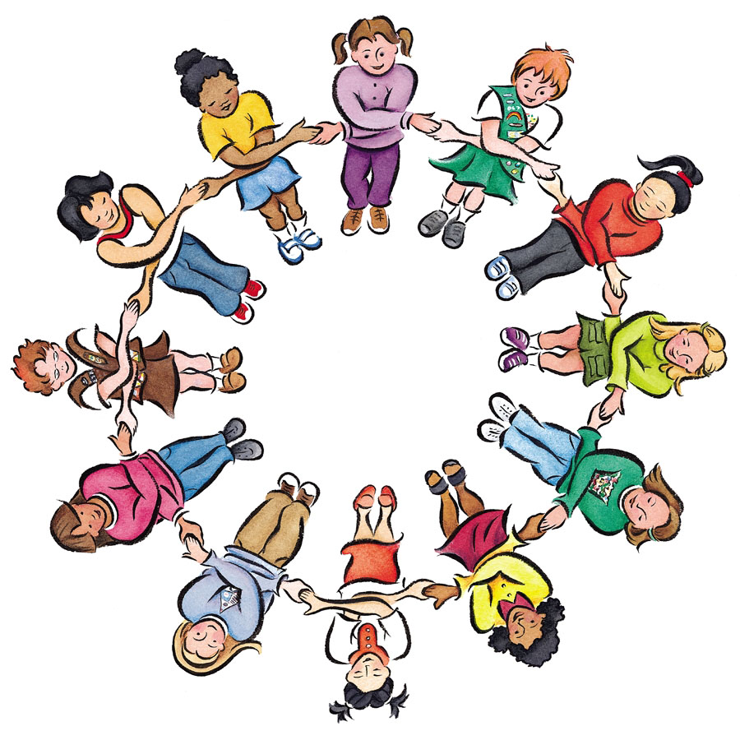

**Introduction**

**What is PSHRE?**

PSRHE (Personal, Social, Health, Relationships and Economic) is a planned programme of learning through which children acquire the knowledge, understanding and skills they need to manage their lives now and in the future.

**The purpose of PSHRE**

PSHRE develops the qualities and attributes pupils need to thrive as individuals, family members and members of society. It prepares them to manage many of the most critical opportunities, challenges and responsibilities they will face growing up in such rapidly changing and challenging times. (PSHE Association 2015).

**Aims**

In September 2020, PSHRE became a statutory curriculum area and along with the core themes of Healthy Living and Relationships, it is a mandatory requirement to teach Health Education and Relationships Education (in primaries).

The teaching of PSHRE will include these themes:

* Mental Well-Being (supported through The Thrive Approach and Headstart)
* Internet Safety and Harms
* Physical Fitness and Health
* Healthy Eating
* Drugs, Alcohol and Tobacco
* Health and Prevention
* Basic First Aid
* Changing Adolescent Body (UKS2)

At Bankfields Primary School, we aim to:

* Provide a broad and balanced curriculum which meets the need of the pupils;
* Promote the spiritual, moral, cultural, mental and physical development of pupils at the school and of society;
* Prepare pupils at Bankfields Primary School for the opportunities, responsibilities and experiences they already face and for later life;
* Encourage the pupils to understand how all actions have consequences and how they can make informed choices to help themselves, others and the environment and to keep themselves safe in a variety of situations.

**PSHRE Curriculum Intent**

In Bankfields, PSHRE (Personal, Social, Health, Relationships and Economic) teaching enables the children to have strategies and knowledge so they become healthy, independent and responsible members of their community and society who are also able to make choices that keep themselves safe. Through mindfulness activities, our children are able to approach their learning in a calm and thoughtful manner. Through teaching about tobacco and alcohol, the children will be able to make informed choices as they grow, and understand which drugs are harmful or helpful and how to stay safe. Staying safe in different situations is woven throughout our PSHRE teaching including preparing our children to stay safe online in a growing technological world. PSRHE teaches our children how important it is to take care of themselves, from looking after their teeth and personal hygiene to having a sense of self-worth. At Bankfields, we value the input from specialist visitors and plan activities which encourage our pupils to have a sense of pride and achievement, where they can confidently share views and opinions in a supportive environment and ask ‘big questions’ to deepen their thinking.

**Curriculum Provision**

PSHRE is delivered within a whole school approach which includes:

* Dedicated curriculum time on a weekly basis and includes circle time;
* Teaching PSHRE through other curriculum areas;
* Pastoral care and guidance including the provision of the Thrive Approach and Headstart;
* Visiting speakers
* Opportunities for child led learning to take place

**Teaching and Learning**

**Early Years and Foundation Stage (from September 2023)**

Personal, Social and Emotional Development is a prime area of the EYFS Curriculum, which includes as its overarching principles:

• every child is a **unique child**, who is constantly learning and can be resilient, capable, confident and self-assured

• children learn to be strong and independent through **positive relationships.**

(Statutory framework for the Early Years Foundation Stage (applies from September 2023)

Children’s personal, social and emotional development (PSED) is crucial for children to lead healthy and happy lives, and is fundamental to their cognitive development. Children will learn how to understand their own feelings and those of others. They will be supported to manage emotions, develop a positive sense of self, set themselves simple goals, have confidence in their own abilities, to persist and wait for what they want and direct attention as necessary. Children will learn how to look after their bodies, including healthy eating, and manage personal needs independently. They will be taught how to make good friendships, co-operate and resolve conflicts peaceably.

The Early Learning Goals that children will develop are Self-Regulation, Managing Self and Building Relationships.

**At key stage 1,** children learn about themselves as developing individuals and as members of their communities, building on their own experiences and on the early learning goals for personal, social and emotional development. They learn the basic rules and skills for keeping themselves healthy and safe, including when they are using internet on a variety of devices, and for making positive choices. They have opportunities to show they can take some responsibility for themselves, including online and in their environment. They begin to learn about their own and other people's feelings and become aware of the views, needs and rights of other children and adults. As members of a class and school community, they learn social skills such as how to share, take turns, play, help others, resolve simple arguments and resist bullying including online bullying.

**At key stage 2,** children learn about themselves as growing and changing individuals with their own experiences and ideas, and as members of their communities. They become more mature, independent and self-confident. They learn about the wider world and the interdependence of communities within it. They develop their sense of social justice and moral responsibility and begin to understand that their own choices and behaviour can affect local, national or global issues and political and social institutions. They learn how to take part more fully in school and community activities. As they begin to develop into young adults, they face the changes of puberty and transfer to secondary school with support provided prior to transition. They learn how to make more confident and informed choices about their health, mental health and environment; to take more responsibility including when they access and use the internet, individually and as a group, for their own learning; and to resist bullying including online bullying.

**Planning**

When planning PSHRE, teachers take into account the variety of teaching and learning styles that will be used. These may include video clips, stories, discussions as well as encouraging child led learning opportunities.

Resources and strategies such as SEAL, The PSHE Association and circle time will be regularly used to challenge children’s ideas and perceptions. Bankfields Primary School are also using Kapow resources. Planning is supported by relevant resources appropriate for each year group.

Planning will encourage active participation by asking the children open ended questions and encouraging them to ask open ended questions. Each time a topic is revisited, the class teacher will ensure it is appropriate to the child’s age, maturity, understanding of the topic and ability.

**Teaching and Learning**

For KS1 and 2 overall key concepts and key knowledge are recorded in teachers’ planning. A variety of strategies including questioning, discussion, concept mapping and marking are used to assess progress. Activities are challenging, motivating and extend pupil’s learning. Lessons make effective links with other curriculum areas, including Literacy, History, Science, Geography and ICT. Activities inspire the pupils to investigate issues that occur locally, and in the world around them and to participate in a range of activities.

Staff use the long term plan to inform their medium and short term planning to ensure that all key concepts and knowledge are taught.

One piece of high-quality work will be evident in children’s books and an additional activity promoting Oracy will be evidenced on Seesaw per half term, reflecting the different key concepts taught throughout the year.

**Cross Curricular Links**

Literacy: in particular at KS1, the pupils are encouraged to use their speaking and listening skills to explain what they feel and what is happening around them. Relevant links are developed through the reading of class novels.

At KS2, the pupils are encouraged to develop their skills of writing and should be applying their literacy skills at levels similar to those which they are using in their English work. Teachers encourage discussion and questions about issues that arise in their whole class novels.

Numeracy: At both key stages the pupils take part in activities that include planning for and carrying out enterprise activities and is linked to financial and economic well-being.

Computing: At both key stages pupils Computing skills are used to locate and research information (Internet, Espresso, access to iPads); record findings (using text, data and tables); and recording using the iPads. Internet Safety is an important aspect of staying safe and this is reinforced during Computing sessions, half termly Internet Safety lessons and Online Relationships sessions taught through PSHRE.

History: In Key Stage 2, the pupils are expected to learn about Crime and Punishments, linking these to the rules and responsibilities that children learn about in PSHRE. In both Key Stages, children learn about the impact of important people through time and ask ethical or moral questions about their impact.

Science: At both key stages, the pupils are taught about the importance of eating healthily, eating a balanced diet and about the human body.

SMSC is evident through other curriculum areas for example history, where children consider the roles of Captain Cook and Gandhi on the people they met; DT, where children consider the carbon footprint related to their work on food technology and Geography, where children look at the places where iron and steel from the local area can be found around the world.

**Assessment**

EYFS follow the agreed assessment created by Steel River Trust which is taken from the Early Years Framework. Early years learning concentrates on 7 areas split between prime and specific areas of learning.

* Communication and Language
* Physical Development
* **Personal, Social and Emotional Development**
* Literacy
* Mathematics
* Understanding the World
* Expressive Arts and Design

Children in Foundation 1 (Nursery) are assessed on entry to Nursery to gain a baseline and again as they leave.

On entry to Foundation 2 (Reception) a baseline is recorded and then children are assessed against the Early Learning goals at the age of 5 at the end of the Foundation Stage.

Throughout the Foundation Stage evidence of learning and development is collected through observational assessment and monitoring and recorded in an Individuals Learning Journey and work book.

Teachers use formative assessment in lessons. Judgments are formed through verbal responses gained through question and answer sessions and through written responses following discussions.

Teqachers assess at the end of each term, each class teacher uses Assessment for Learning data sheets focussed on the objectives taught in that term. Using this information, the PSHRE Coordinator can plan actions for specific groups of children.

It is the responsibility of the subject leader to monitor the progress of PSHRE across the school with reference to specific action points outlined in the PSHRE action plan. Using data collected, a clear picture of attainment can be seen and future actions can be highlighted and addressed.

**Inclusion/SEN/G&T**

Planning at all levels ensures that account is taken of race, gender and special educational needs, as well as catering for the range of ability within the class. The pupils work individually, in pairs, as part of a small group and as a whole class each term. They use a variety of means for communicating and recording their work. All pupils, including those with special educational needs undertake the full range of activities and identified children are supported within the group. Children that are gifted and talented are identified and highlighted on the G&T register and are given extension work to challenge their thinking and understanding even further.

**Roles and Responsibilities**

**How is PSHRE monitored and evaluated?**

The subject leader will coordinate the implementation of the school PSHRE action plan and monitor progress against the targets identified in the action plan. PSHRE in curriculum books, floor books and other sources of recording (e.g. video) will be monitored to show evidence of differentiation, coverage and progression across the key stages. Co-coordinator / team planning sessions and feedback regarding planning, learning and assessment will take place to support development in PSHRE throughout the year. Planning will show coverage of topics, key knowledge, concepts and questions developed in each theme. Evidence of themes will be displayed in the classroom environment, observations, photographs, samples of work and in a class floorbook. Opportunities for Oracy within PSHRE will be recorded on Seesaw. The termly school coverage grid for PSHRE will monitor the areas of PSHRE that has been taught and cross curricular links will be identified.

**Support staff**

Educational support staff work as directed by the teacher. They are able to refer to a planning sheet for the particular group with whom they are working, seek additional resources and adapt planning as directed by the class teacher. Guidance regarding question types and related vocabulary to be used with children are highlighted on planning sheets.

**Promoting PSHRE**

Through teaching PSHRE, teachers include sessions that address the children's needs as they arise (additional anti-bullying sessions, community themed sessions) and sessions which address local or national issues. Outside agencies and organisations provide links to the greater community and offer a wider experience for children to engage in fun and interesting themes reflecting the diversity within our society.

**Parental and Community Involvement**

**Parents and Governors**

**Parents** are kept informed of activities and children’s progress in PSHRE through:

Parent Mail;

Marvellous Me (EYFS);

Seesaw

Family learning days;

Parent consultation evenings and drop in sessions;

Bankfields Primary Facebook page;

End of year reports.

**Governors** are kept informed of activities and developments in PSHRE through:

Governor training;

Meeting with the PSHRE coordinator